**AI CODING**

## **ASSIGNMENT-4.4**

2403A51271

MOHAMMED ZIAUDDIN

**Task 1: Auto-Complete a Python Class for Bank Account**

**CODE:**

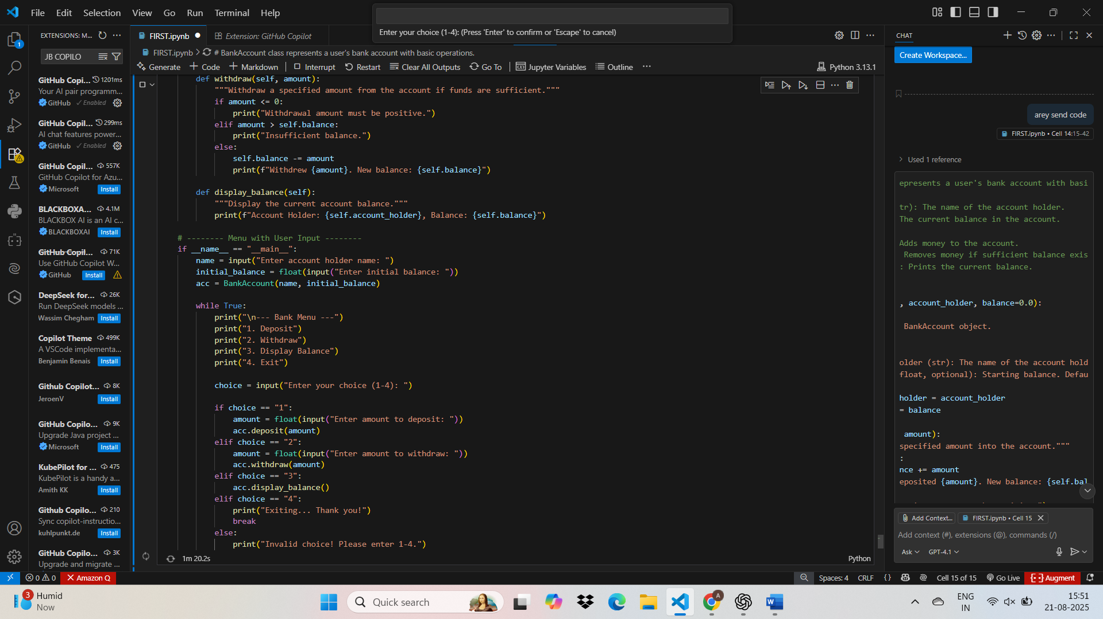

**OUTPUT:**

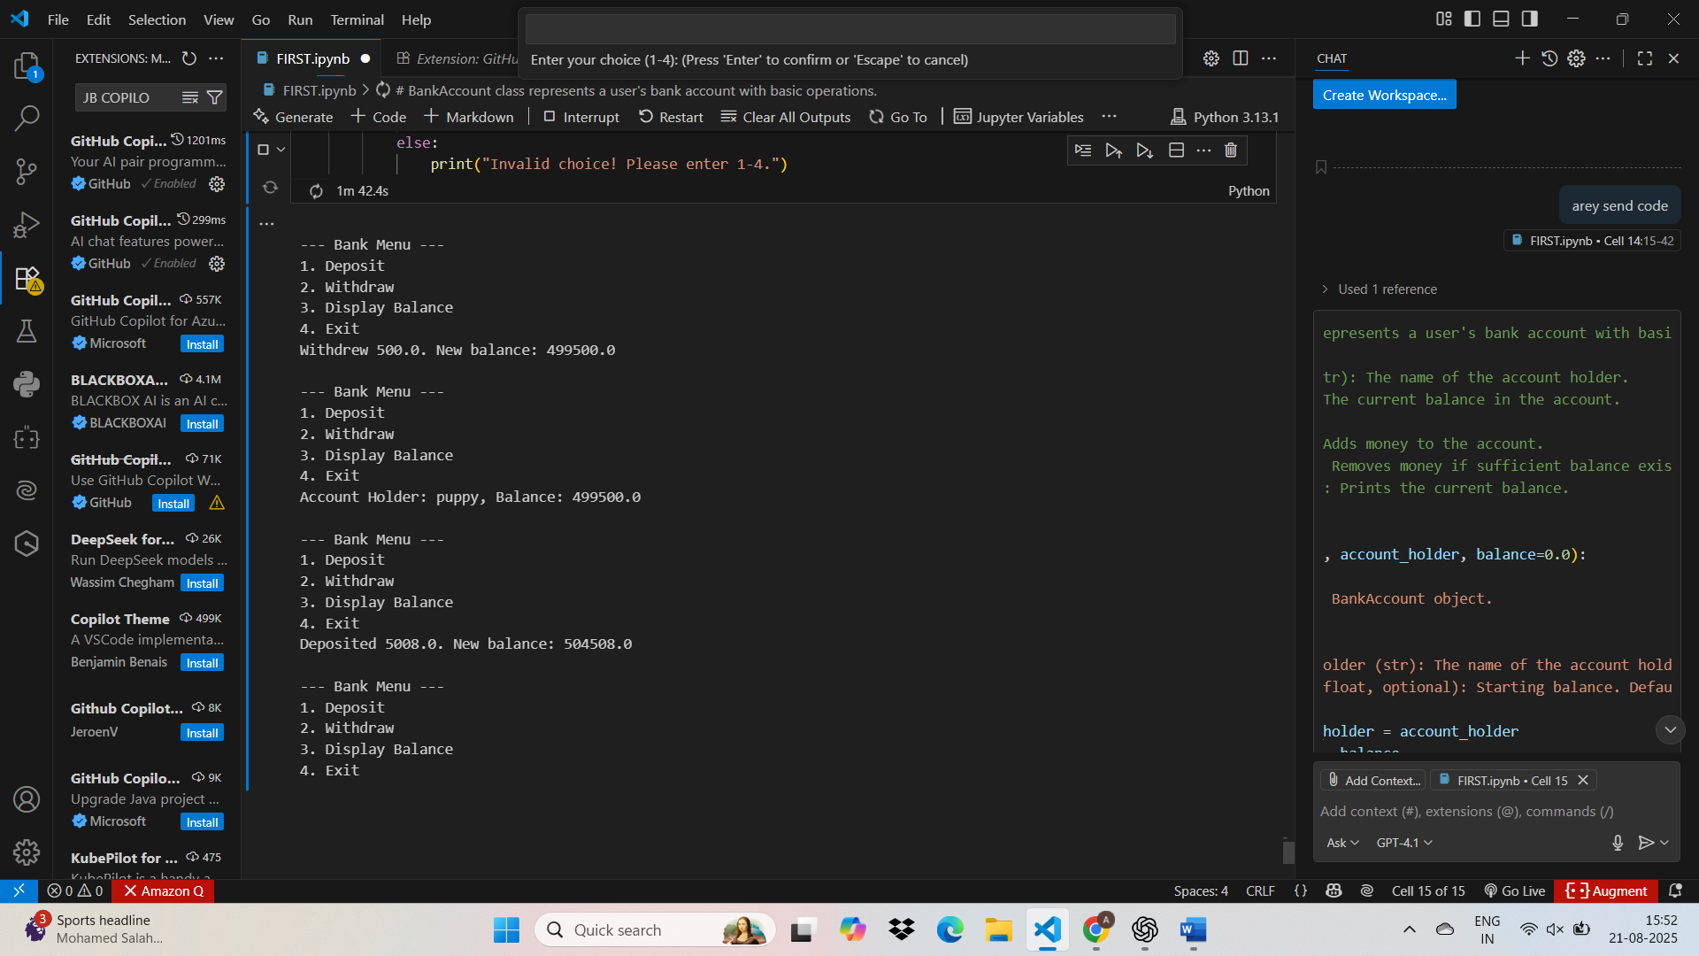

**Task 2: Auto-Complete a For Loop to Sum Even Numbers in a List**

**CODE WITH OUTPUT:**

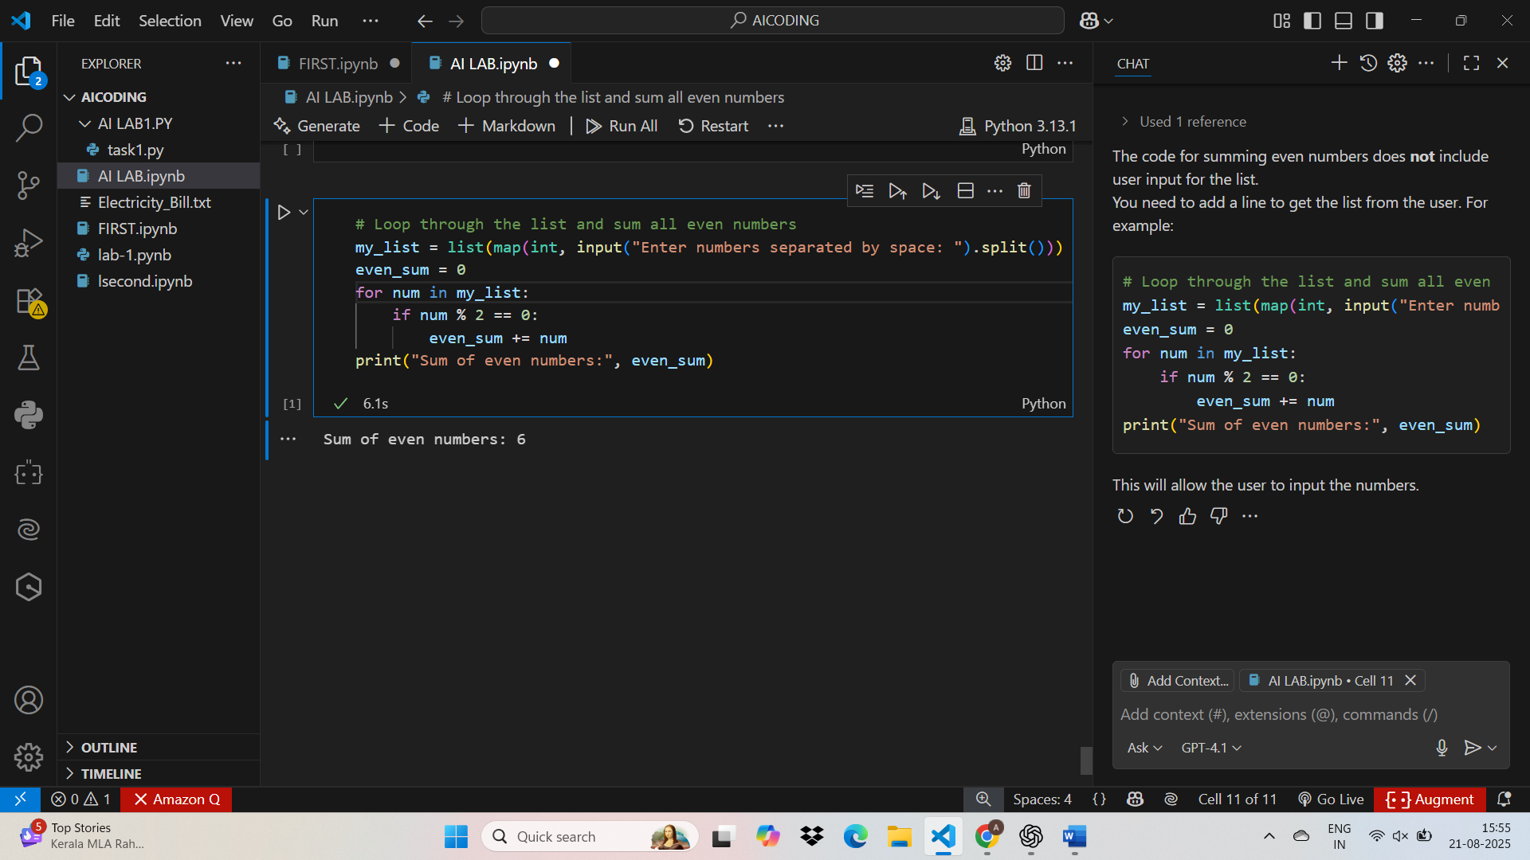

**Task 3: Auto-Complete Conditional Logic to Check Age Group**

**CODE WITH OUTPUT:**

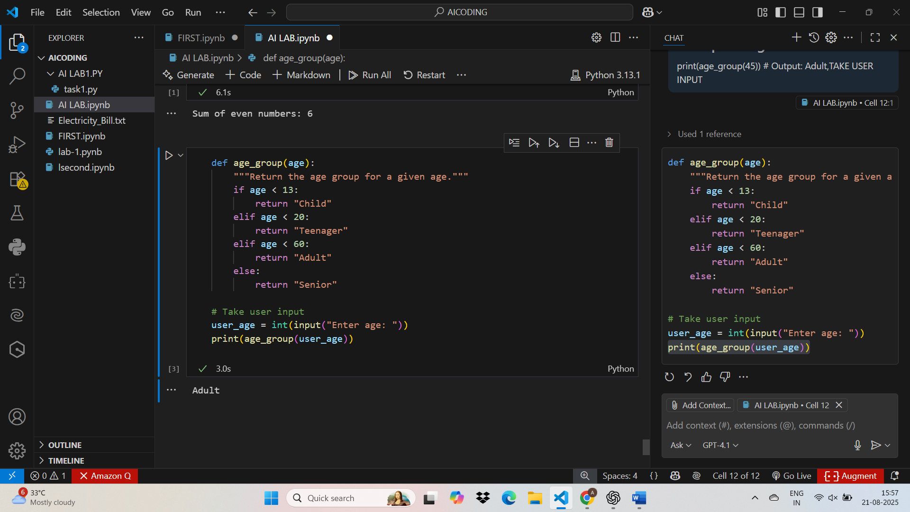

**Task 4: Auto-Complete a While Loop to Reverse Digits of a Number**

**CODE WITH OUTPUT**

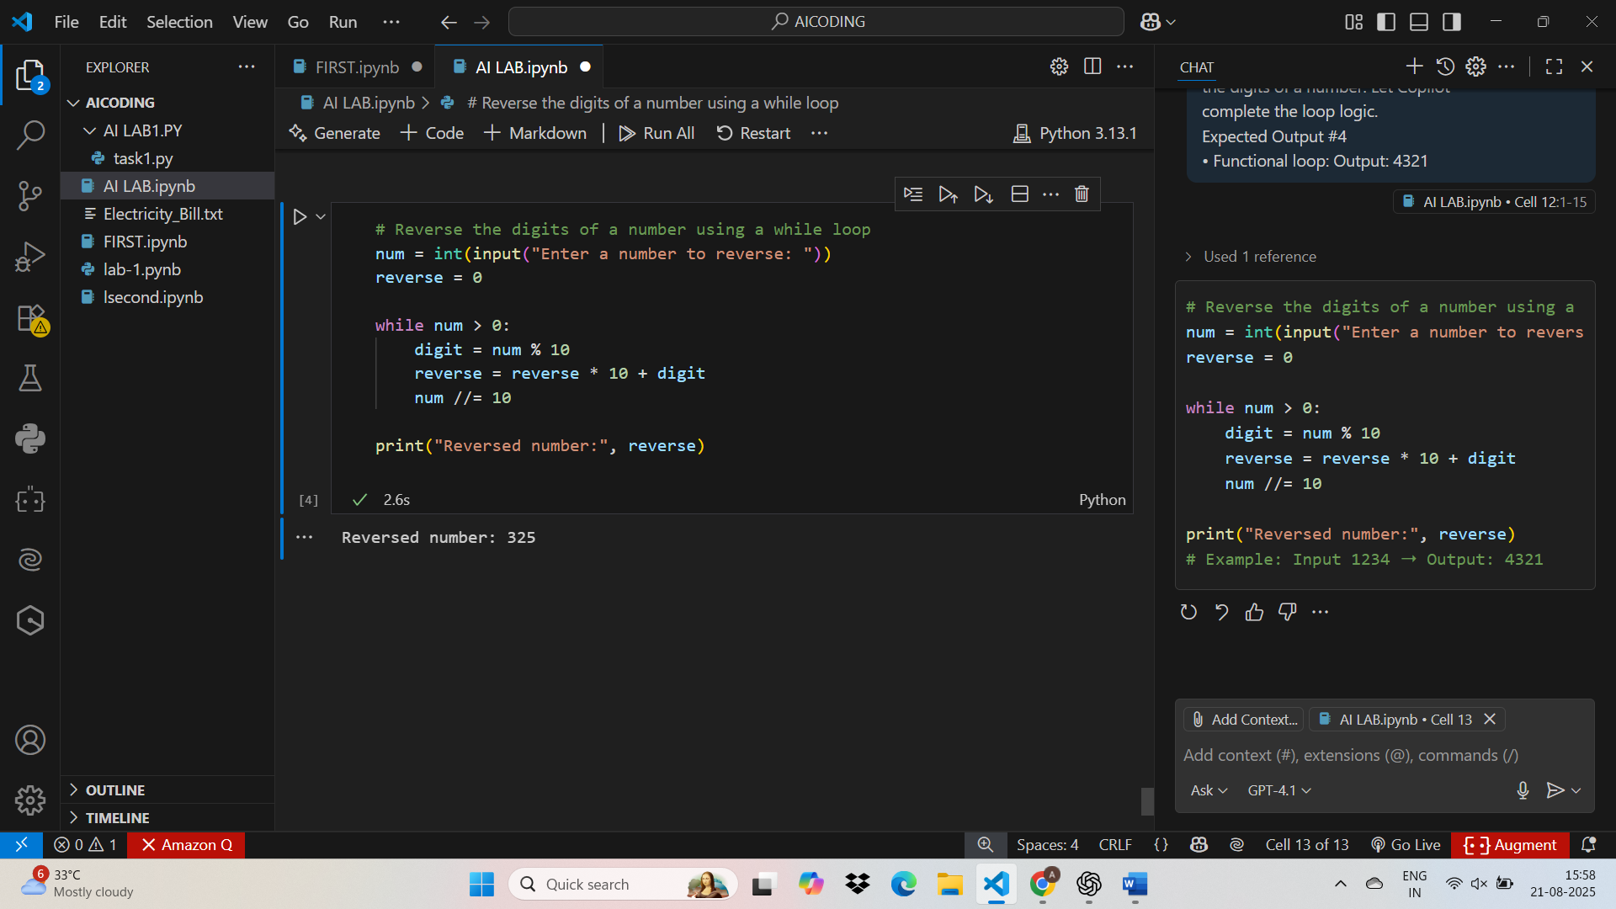

**Task 5: Auto-Complete Class with Inheritance (Employee → Manager)**

**with output:**

